Summer food safety: don’t leave home without it!

Summer is finally upon us in Alberta! Whether you are staying close to home, camping, or attending festivals, take steps to keep food safe.
Much like applying sunscreen to protect your skin from the sun, understanding and using proper food safety measures can protect yourself, family, and friends.
Food poisoning or foodborne illness is a major cause of illness in Canada. In Canada, one in eight people get sick each year from eating contaminated food. This is nearly four million people each year.
Food poisoning is caused by eating foods that have harmful germs in them. Symptoms are usually mild, but severe illness, hospitalization and even death can happen because of these germs.
Did you know that you can’t always tell if food has gone bad by look, smell, or taste? Germs are small and not easily detected. This article offers food safety tips along with ideas to ensure the safety of your food during your summer activities.

Food safety tips!
- When grocery shopping, buy cold or frozen food at the end of your shopping trip.
- Check the expiry dates on packages.
- Wash your reuseable grocery bags often.
- Wash your hands before and after handling food.
- Store foods safely. Refrigerate raw meat, fish, poultry as soon as possible or within two hours. Make sure your fridge is set to 4°C(40°F) or lower, for freezer -18°C(0°F)
- Thaw meats in the fridge, under cold running water or in the microwave. Germs can grow at room temperature. Cook foods soon after thawing.
- Use a clean meat or food thermometer to make sure foods are cooked to a safe temperature.
- Use separate cutting boards for ready-to-eat foods (vegetables and fruits) and another for raw meat.
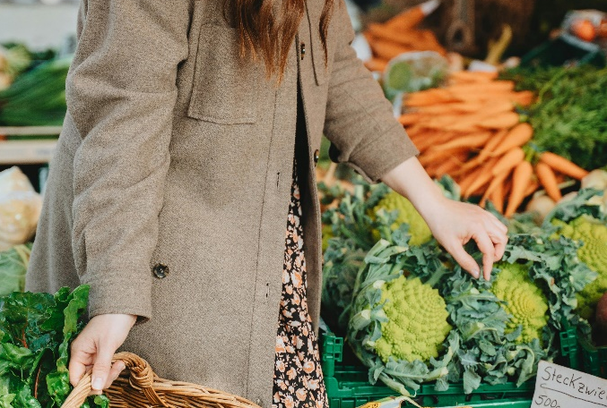
- Use different plates and cooking utensils for raw and cooked foods.
- Serve hot foods hot and cold foods cold.
- Chill leftovers as quickly as possible, using a shallow container to cool the food down quicker.
Grilling at home
- Marinate foods in the fridge not on the counter or outdoors.
- Do not use sauce that was used to marinate raw meat or poultry on cooked food.
- Cook ground meat thoroughly. Ground beef can turn brown before dangerous germs are killed. Use a food thermometer to take the temperature in the thickest part of the meat. Cook until the thermometer reads at least 71°C (160°F).
- Cook meat like roasts and steaks to 63°C (145°F) on the inside.
- Cook ground meat to 71°C (160°F) on the inside.
- Flip meat at least twice to cook it evenly.
Picnics and camping
- When packing foods in a cooler, pack foods that you are likely to use last on the bottom. Pack plenty of ice or freezer packs to ensure a constant cold temperature.
- Fill a cooler to capacity. A full cooler maintains its temperature better than one that is partially filled. Keep the cooler out of direct sunlight and avoid opening it too often.
- Bring a food thermometer for your meat and poultry to ensure your meat has reached a safe internal temperature when cooking.
- Don’t let food sit out for more than two hours.
Snacks for outdoor events/festivals
- Bring disposable wipes or hand sanitizer with you to use before and after handling food if you aren’t near a handwash station. Handwashing is the preferred method for washing hands.
- Take only the amount you think you will need so you don’t have leftovers.
- Consider taking foods and snacks that do not need to be refrigerated like fresh or canned fruit, trail mix, crackers, or granola bars.
Remember: if in doubt, throw it out
For more information, check out the Food Safety page on Canada.ca.
Using these tips can help you and your loved ones enjoy your summer activities and stay safe.

v

Wellness Articles
Alberta Health Services encourages all Albertans to live a healthy life. These weekly Wellness Articles are created by a team of healthcare professionals from AHS in collaboration with
provincial healthcare experts in Alberta and content from myhealth.alberta.ca.
Our experts ensure this information is factual, current, and written for Albertans.
From stress-relief strategies to finding balance within your life, these Wellness Articles cover a
variety of different topics designed to inspire and educate Albertans on creating a positive and
healthy lifestyle.
We welcome and encourage weekly newspapers, community newsletters and other publications
to reproduce this information free of charge. Please credit Alberta Health Services or the identified
content provider.
If you would like to be added to the distribution list for these articles, please email: rebecca.johnson2@ahs.ca. You will receive a monthly email containing articles for the
upcoming four weeks.

