Sport and Recreation Safety
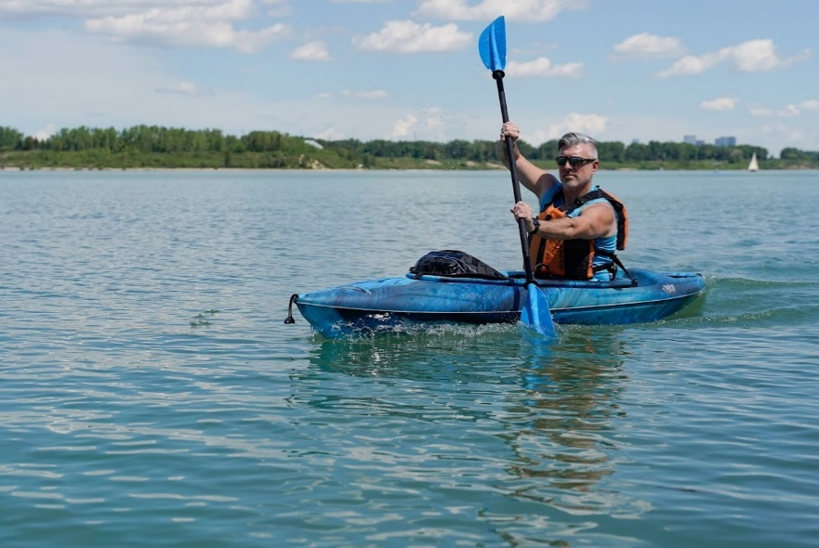
Stay safe while taking part in sport and recreation activities. You can do your part in reducing chances of falling, getting hurt, or having a serious injury.
Teens and children are also at risk of injury as they take part in sports and summer recreation. In Alberta, getting hurt while playing a sport is the top cause of the emergency department visits related to injuries for youth ages 10 to 19.
Following these tips will lower everyone’s risk of getting hurt while playing sports and enjoying recreation activities:

Check the environment to reduce or avoid hazards
To improve safety, look for hazards. A hazard is something dangerous that may not be obvious but that can cause serious injury. Examples of hazards include thin ice on a frozen lake, broken equipment, or an icy sidewalk.
A risk is different. A risk is a situation where you can see the chance of an injury happening, think about the challenge, and decide what to do.
Your challenge is to learn to recognize, reduce, or avoid hazards, while having the chance to explore and accept the level of risk you’re comfortable with.
For example, when you are out walking on a nature trail and see a hole, root, or wet section on your path (a hazard), you can:
- Prepare for the hazard by walking slowly and making sure you have the right shoes and equipment for your walk.
- Reduce the hazard by walking during daylight hours when the trail is well-lit.
- Avoid the hazard by walking on clean, well-maintained trails, or finding a path around the hazard when you can.

Wear protective gear
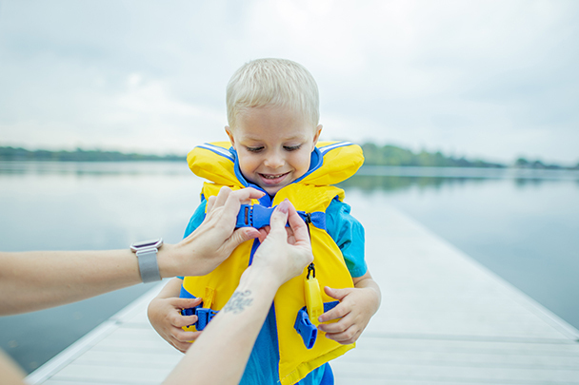
Wearing protective gear like a helmet, mouth guard, elbow pads, knee pads, or lifejacket (if participating in water-related activities) can lower your risk of an injury. No matter what the activity, make sure you use the right gear and equipment. The gear should fit and be worn properly every time.

Develop skills!
Prepare and plan before starting a sport or activity. This includes getting your gear together and warming up. Warm-up programs that include aerobic (activities that bring up your heart rate), balance, strength, and agility (being able to move quickly and easily) exercises may help reduce the risk of injury.
Training and practice help you learn how to do an activity and get better at it. They also help lower your risk of getting hurt by teaching you how to participate in an activity safely. If you don’t know how to do an activity, start slowly to develop skills. Think about taking lessons to learn or improve how you ski, skate, bike, or play a sport. Take lessons from someone who knows how to teach the skills, like a trained coach or professional. They can help with both skill development and safety.

v

Wellness Articles
Alberta Health Services encourages all Albertans to live a healthy life. These weekly Wellness Articles are created by a team of healthcare professionals from AHS in collaboration with
provincial healthcare experts in Alberta and content from myhealth.alberta.ca.
Our experts ensure this information is factual, current, and written for Albertans.
From stress-relief strategies to finding balance within your life, these Wellness Articles cover a
variety of different topics designed to inspire and educate Albertans on creating a positive and
healthy lifestyle.
We welcome and encourage weekly newspapers, community newsletters and other publications
to reproduce this information free of charge. Please credit Alberta Health Services or the identified
content provider.
If you would like to be added to the distribution list for these articles, please email: rebecca.johnson2@ahs.ca. You will receive a monthly email containing articles for the
upcoming four weeks.

