Staying active in hot weather
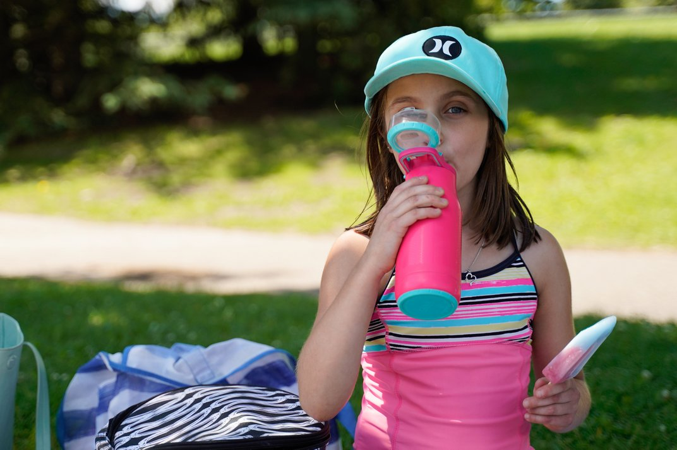
Summer is a great time for being active but heat and humidity can present challenges. If the temperature is lower than 27°C, you usually can be active outside without taking extra precautions, depending on how active you already are and how much you are used to hot weather. These tips can help you stay safe when being active as the summer months heat up.
- Drink plenty of water. You lose fluid when you are active. If you lose too much, it can result in dehydration, muscle cramps, or even heat exhaustion. In hot weather, drink plenty of fluids before, during, and after activity. For longer exercise periods, sports drinks contain carbohydrates and minerals called electrolytes that may help prevent dehydration.
- Don't exercise as hard when it's hot. Take rest breaks. Exercise more slowly than usual or for a shorter time.
- Stay in the shade when you can.
- Wear light-coloured, breathable clothes.
- Always wear sunscreen.
- Watch for signs of dehydration and heat-related illnesses such as heat exhaustion and heatstroke. Signs of dehydration include having a dry mouth and eyes and feeling dizzy.
If you are overweight, have health problems, take medicines, or use alcohol, you may be at a higher risk for heat-related illness. You may also have trouble if you are not used to exercising in warmer weather. Older adults and children are at a higher risk for heat-related illness and should be extra cautious. Remind children to drink plenty of fluids before, during, and after activity.

Taking extra precautions
When it's hot and humid out, take extra precautions when you're active. This might mean you change your activity or when you choose to do it. Here are some ideas you can try:
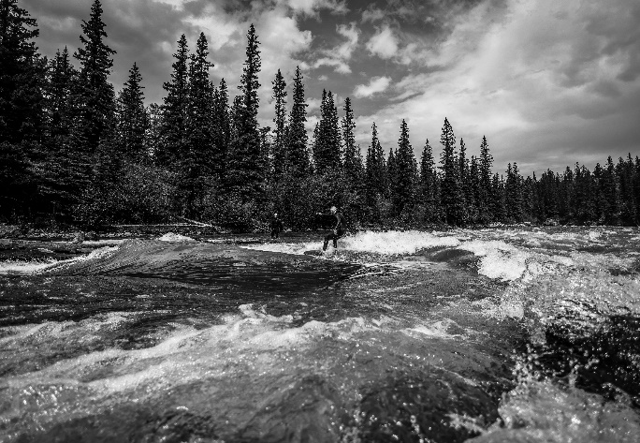
- Take morning or evening walks.
- Walking the dog or walking with a partner helps you make it part of your routine.
- Go for a bike ride.
- Find shaded areas, and ride during cooler times of day.
- Go swimming on hot days. This is a healthy family activity for summer.
- Do light yard work or gardening. You'll burn calories while you keep the yard looking good.
- Wash your car. This gets you outside and helps you burn calories. Give yourself a splash to stay cool.
Sometimes it isn't safe to be active outdoors. There are many ways to be active indoors. Here are a few ideas:
- Go for walks—indoors. Take a walk at the mall with a friend. Or check with local schools or places of worship. They may have indoor gyms where you can walk.
- Get fit while you watch TV or listen to music. Get some hand weights or stretch bands. You can use cans of food as weights if you don't want to buy weights.
- Use an online exercise video or a smartphone app. This can be a fun way to stay active at home.
- Do active housework. This may include activities such as sweeping, mopping, vacuuming, doing laundry, or washing the windows.
- Join a gym or health club. You can use equipment like weights, treadmills, stair-climbers, or exercise bikes.
- Try a fitness class or a new indoor activity. Examples include dancing and water aerobics. Many cities have community centres that offer affordable fitness classes.
- Get involved in indoor sports leagues. Many cities offer indoor sports like basketball, volleyball, indoor soccer, or swimming.

v

Wellness Articles
Alberta Health Services encourages all Albertans to live a healthy life. These weekly Wellness Articles are created by a team of healthcare professionals from AHS in collaboration with
provincial healthcare experts in Alberta and content from myhealth.alberta.ca.
Our experts ensure this information is factual, current, and written for Albertans.
From stress-relief strategies to finding balance within your life, these Wellness Articles cover a
variety of different topics designed to inspire and educate Albertans on creating a positive and
healthy lifestyle.
We welcome and encourage weekly newspapers, community newsletters and other publications
to reproduce this information free of charge. Please credit Alberta Health Services or the identified
content provider.
If you would like to be added to the distribution list for these articles, please email: rebecca.johnson2@ahs.ca. You will receive a monthly email containing articles for the
upcoming four weeks.

