Bike Safety for Everyone
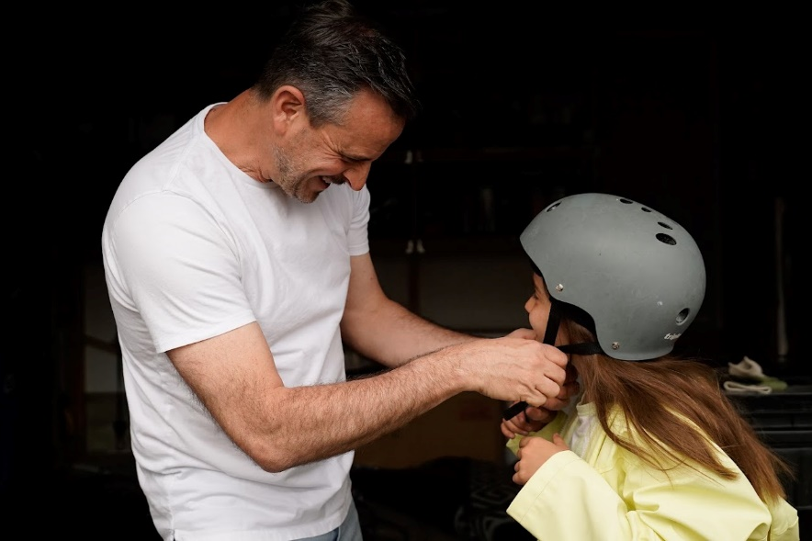
Biking can be a great way to get around and to keep fit. To ride safely though, good balance, control, strength, and judgement are key tools to remember each time you get on your bike.
Here are some important safety tips to lower the risk of injuries while biking:
- Obey the same rules when you ride on the road as you do when you drive a car. This includes riding on the right side of the road so you're going in the same direction as traffic and stopping at all intersections.
- Look behind you (shoulder check) each time you turn or move out to pass.
- Learn and use hand signals.
- Look left, right, and left again before going ahead.
- Watch the road for hazards like debris, grates, or holes.
- Be extra careful in wet or cold weather that could affect the road conditions or how well you can see.
- Watch for people walking, animals, and others on bicycles when you ride in shared spaces like bike paths or trails.
- Plan your route and choose the safest way to your destination.
- Ensure your bike fits you correctly. Adjust the seat to fit your height. Ensure your bicycle is working properly, and do an ABC quick check before every ride: A for air (make sure the tires are firm), B is for brakes, bar, and bell (check your brake levers are working, handlebars are at the right height, and test your bell.)

Do you have protective gear?
Bike helmets protect people of all ages. It's the law in Alberta that anyone younger than 18 years must wear a helmet when riding a bicycle. Here are some things to consider when selecting a helmet and ensuring you will be well protected on your bike:
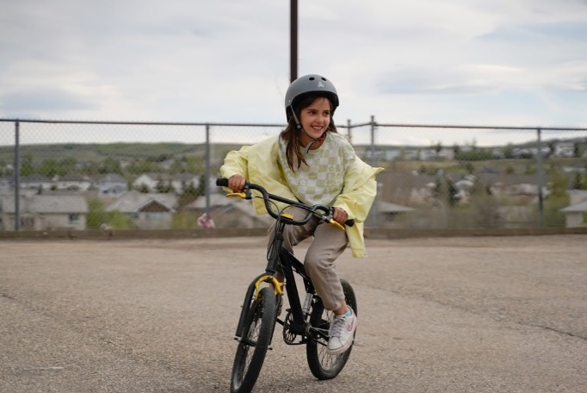
- Make sure your bike helmet meets current, approved helmet safety standards. (Look for a CSA, Snell, or ASTM sticker to know if the helmet is approved.)
- Take the Bike Helmet YES Test to make sure your helmet fits properly. It should be snug, level, and stable.
- Replace your helmet every five years, or whenever recommended by the helmet manufacturer or, after you've been in a crash.
- Set a good example for children by wearing your bike helmet.
- Let your child choose their own bike helmet because they'll be more likely to wear it.
Other protective gear includes things like a bell or horn for your bike, gloves for a better grip on the handlebars, proper supportive shoes, reflective tape, reflectors, and lights so it's easier to see you at night. Reflectors should be on the front, back, and spokes of the bicycle. Wear bright clothing during the day so it’s easier for other people to see you on your bike.

Staying safe while riding with children
Children can often ride a bicycle before they understand how to be safe. Children aren't ready to ride alone until they understand road safety rules, know how to signal, and know how to avoid major risks. When riding bicycles, young children should always:
- Ride with an adult.
- Ride in a single line behind an adult who knows how to ride safely.
- Use hand signals.
- Get off their bicycles to cross the street.
Most children have the skills they need to ride on the road alone at 10-years-old. But every child is different, so supervise actively. Stay where you can see, hear, and reach them, and pay close attention to what they’re doing. Lead by example and show children how to be safe. Teach them the safety rules and make sure they follow them.

v

Wellness Articles
Alberta Health Services encourages all Albertans to live a healthy life. These weekly Wellness Articles are created by a team of healthcare professionals from AHS in collaboration with
provincial healthcare experts in Alberta and content from myhealth.alberta.ca.
Our experts ensure this information is factual, current, and written for Albertans.
From stress-relief strategies to finding balance within your life, these Wellness Articles cover a
variety of different topics designed to inspire and educate Albertans on creating a positive and
healthy lifestyle.
We welcome and encourage weekly newspapers, community newsletters and other publications
to reproduce this information free of charge. Please credit Alberta Health Services or the identified
content provider.
If you would like to be added to the distribution list for these articles, please email: rebecca.johnson2@ahs.ca. You will receive a monthly email containing articles for the
upcoming four weeks.

