Stroke prevention and you
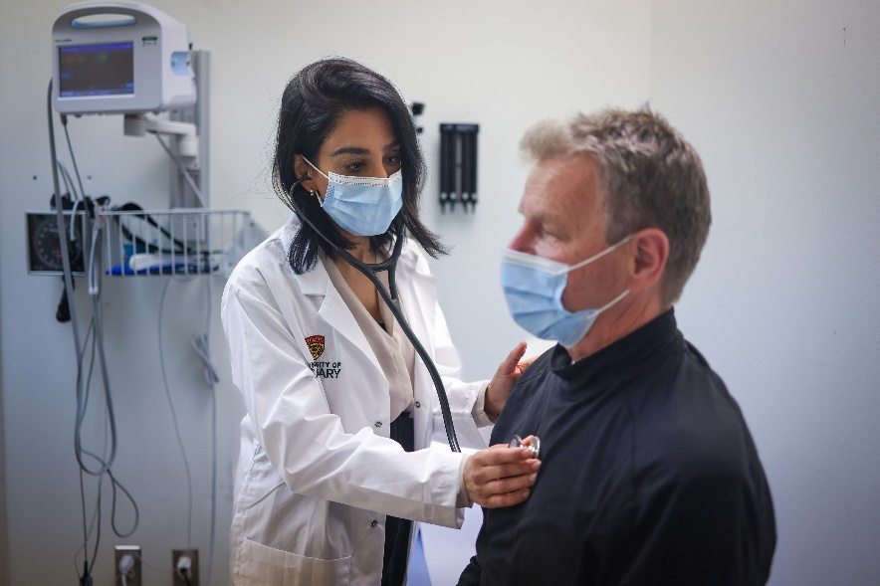
It is important to learn the signs of stroke, not only to protect yourself but your loved ones around you. But first, let’s start with the basics. What is a stroke?
A stroke is damage to the brain that occurs when a blood vessel in the brain bursts or is blocked by a blood clot. Without blood and the oxygen it carries, part of the brain starts to die. The part of the body controlled by the damaged area of the brain can't work properly. Brain damage can start within minutes of a stroke, so it is important to act quickly because timely treatment can help limit the damage and increase the chance of a full recovery.

Causes and symptoms of stroke
There are two types of stroke which have different causes:
An ischemic (say "iss-KEE-mick") stroke is caused by a blood clot that blocks blood flow to the brain. A blood clot can form in an artery that supplies blood to the brain. Or a blood clot can form in another part of the body (often the heart) and travel through the bloodstream to the brain. Ischemic strokes are the most common type of stroke.
A hemorrhagic (say "heh-muh-RAW-jick") stroke is caused by bleeding in or around the brain. It happens when an artery in the brain leaks or bursts. Hemorrhagic strokes are less common than ischemic strokes.
Symptoms can happen suddenly, so knowing what to look for can ensure you or your loved one is treated quickly. The best way to remember stroke symptoms is by using the acronym FAST.
- Face – is it drooping?
- Arms – can you raise both?
- Speech – is it slurred or jumbled?
- Time – to call 9-1-1 right away
Other stroke symptoms include loss of balance or trouble walking, trouble seeing out of one or both eyes, sudden confusion, sudden trouble understanding simple statements, fainting, a seizure, and a sudden, severe headache.
When you know what stroke symptoms are, you will know when it's important to call for medical help. Quick treatment can limit damage from a stroke, and it may save your life or someone else's life.

Stroke Prevention
Managing health problems such as atrial fibrilization, diabetes, high blood pressure, and high cholesterol can minimize the risk of stroke but there are other ways to prevent.
Some examples include:
- Maintaining a heart-healthy lifestyle, including healthy eating and regular physical activity. Include heart-healthy foods like vegetables, fruits, nuts, beans, lean meat, fish, and whole grains. Limit sodium and sugar.
- Ensure you incorporate at least 2.5 hours of moderate to vigorous exercise a week. Walking is an easy, low-impact option but other activities can include running, swimming, cycling, or playing tennis or team sports. For more information, see Fitness and Exercise.
- Don't smoke. If you need help quitting, talk to your doctor about stop-smoking programs and medicines. These can increase your chances of quitting for good.
- Limit alcohol intake
- Stay at a healthy weight
- Limit and manage stress
- If you are diabetic, it is important to control your diabetes. To learn more about how to manage your diabetes, see Diabetes.
If you think you may have a problem with alcohol or drug use, talk to your doctor. If you use hormone therapy for menopause or hormonal birth control, talk with your doctor. Ask if these are right for you. They may raise the risk of stroke in some people. Decide with your doctor whether you will also take medicines to help lower your risk. For example, you and your doctor may decide you will take a medicine that prevents blood clots.

v

Wellness Articles
Alberta Health Services encourages all Albertans to live a healthy life. These weekly Wellness Articles are created by a team of healthcare professionals from AHS in collaboration with
provincial healthcare experts in Alberta and content from myhealth.alberta.ca.
Our experts ensure this information is factual, current, and written for Albertans.
From stress-relief strategies to finding balance within your life, these Wellness Articles cover a
variety of different topics designed to inspire and educate Albertans on creating a positive and
healthy lifestyle.
We welcome and encourage weekly newspapers, community newsletters and other publications
to reproduce this information free of charge. Please credit Alberta Health Services or the identified
content provider.
If you would like to be added to the distribution list for these articles, please email: rebecca.johnson2@ahs.ca. You will receive a monthly email containing articles for the
upcoming four weeks.

