Celebrate, elevate, and enjoy: Nutrition for older adults
Let’s celebrate getting older and aging healthfully. There are many aspects of aging that are out of our control, but food and nutrition research indicates there are many things that can be helped.
If you are, or know someone, who is 65 years or older and lives independently or with others, this article may interest you. It will cover things we do in our life that can give us the best chance of maintaining good nutrition and health.
Weight loss is often seen as a positive topic that is promoted on social media and with family and friends. There are some medical conditions where weight loss is helpful in prevention or management like in Type 2 diabetes and fatty liver disease, but it can present a risk for older adults. When we lose weight, we don’t’ just lose fat. We also lose muscle. People can start to lose muscle as early as age 30, but muscle loss increases quickly after age 70, independent of weight loss. Muscle is hard to regain in older adults. Generally, weight loss is not recommended in older adults. Maintaining weight and muscle is important to help you maintain your strength.

The importance of adding in protein to your diet
Protein is a nutrient that helps you to keep the muscle you have. Many seniors do not get enough protein. Since your body can’t store protein in your body, you need to eat higher protein foods, at least three times each day – every day – to maintain the muscle you have.
Try to consume protein foods at each meal. Here are some practical ways you can get more protein at meals and snacks:
- Add cheese, nut butter, or beans to toast
- Make an omelet for breakfast
- Mix 1–2 tablespoons of skim or whole milk powder or a scoop of protein powder into your cereal or yogurt
- Add beans or meat (example wild game or fish) to pasta or vegetable dishes
- Try adding a plant-based protein, like chickpea falafel or tofu to a stir-fry
- Choose nuts, boiled eggs, Greek yogurt, or cottage cheese as a snack

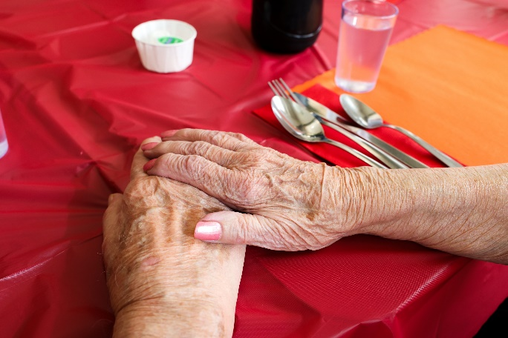
Elevate your eating experience
Enjoyment of eating and quality of life are important for good health. If older adults have a health condition, such as diabetes or health disease, they may have been told to eat a special diet. If your heart healthy, low sodium, or diet for diabetes is affecting your appetite, it is important to talk to your healthcare team about making some changes to make your diet less restrictive.
Other ways to elevate the eating experience is to make the dining environment pleasant. Research shows that eating with others (like at work or with family, friends, or neighbours) makes it more likely to eat more food. Mealtime can be a time for nourishment and socializing. One way that can make having a meal together is hosting a potluck.
Visit ahs.ca and search Shift to Healthy Eating at Work find great potluck ideas for work or any gathering.
Emphasizing enjoyable, social mealtimes as well as nutritious foods are ways to age healthfully to maintain strength and vitality.

Mix it up!
Adding activity into your day shouldn’t feel like a chore or a punishment. It should be fun! Choose activities that you enjoy and mix it up with different types of exercise.
The goal of aerobic fitness is to increase the amount of oxygen that goes to the heart and muscles which allows them to work longer.

v

Wellness Articles
Alberta Health Services encourages all Albertans to live a healthy life. These weekly Wellness Articles are created by a team of healthcare professionals from AHS in collaboration with
provincial healthcare experts in Alberta and content from myhealth.alberta.ca.
Our experts ensure this information is factual, current, and written for Albertans.
From stress-relief strategies to finding balance within your life, these Wellness Articles cover a
variety of different topics designed to inspire and educate Albertans on creating a positive and
healthy lifestyle.
We welcome and encourage weekly newspapers, community newsletters and other publications
to reproduce this information free of charge. Please credit Alberta Health Services or the identified
content provider.
If you would like to be added to the distribution list for these articles, please email: rebecca.johnson2@ahs.ca. You will receive a monthly email containing articles for the
upcoming four weeks.

