Understanding Tuberculosis
Alberta Health Services is bringing awareness to World Tuberculosis Day on March 24. Learning about this contagious infection can support better health for all Albertans.

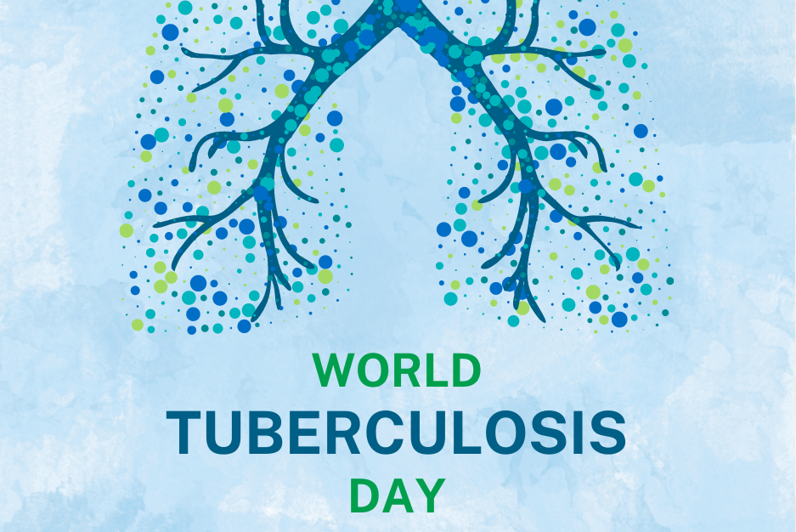
What is Tuberculosis?
Tuberculosis (TB) is an infection caused by slow-growing bacteria. It commonly affects the lungs, but can also affect the kidneys, brain or spine. It is preventable and can be cured by treatment with antibiotics.
Like many airborne illnesses, TB is contagious and spreads when a person who has active TB breathes out air that has the TB bacteria in it. An infected person releases even more bacteria through laughing, coughing, or sneezing.
TB bacterium grows best in areas of the body that have lots of blood and oxygen. That's why it is most often found in the lungs. This is called pulmonary TB. But TB can also spread to other parts of the body, which is called extrapulmonary TB.

Symptoms of Tuberculosis
If you have TB, you might have:
- A bad cough that lasts longer than 2 weeks and makes you cough up blood or phlegm sometimes
- Chest pain, weakness or tiredness
- Lack of appetite, weight loss
- Chills, fever and night sweats
If you have symptoms or have been exposed to someone with TB, Call your health care provider or Health Link at 811. If you do not have a family doctor, visit Alberta Find a Doctor.

Who is most at risk for Tuberculosis?
Some people are more at risk for TB than others. This includes those who:
- Have been around people known or suspected to have TB
- Have had TB in the past but did not complete treatment as prescribed
- Live or work in a community with high rates of TB
- Visit and stay in countries with high rates of TB
- Have a weakened immune system

If you don’t have stable, safe, permanent housing or have trouble finding health care (for example, you live in a remote area) you may be at higher risk of getting TB.

How is Tuberculosis treated?
Treatment is often a success, but it is a long process. It usually takes about six to nine months to treat TB. But some TB infections need to be treated for up to two years.
In most cases, your health care provider will combine four antibiotics to treat active TB. It’s important to take the prescribed medicine for active TB for at least six months. Almost all individuals with TB are cured if they take their medicine as prescribed.
If tests still show active TB after six months, then treatment continues for another two or three months. If the TB bacteria are resistant to several antibiotics (multidrug-resistant TB), then treatment may be needed for a year or longer.
If active TB is not treated, it can damage your lungs or other organs and can be deadly. You can also spread TB by not treating it and seeking proper care.
Did you know? In 2023, there were approximately 245 active cases of TB in Alberta, according to AHS TB Services.

World Tuberculosis Day
World Tuberculosis Day or World TB Day is on March 24, a date that is significant because it commemorates when Dr. Robert Koch announced his discovery of Mycobacterium tuberculosis. This is a day to educate the public about the impact of tuberculosis and raise awareness of this disease.

v

Wellness Articles
Alberta Health Services encourages all Albertans to live a healthy life. These weekly Wellness Articles are created by a team of healthcare professionals from AHS in collaboration with
provincial healthcare experts in Alberta and content from myhealth.alberta.ca.
Our experts ensure this information is factual, current, and written for Albertans.
From stress-relief strategies to finding balance within your life, these Wellness Articles cover a
variety of different topics designed to inspire and educate Albertans on creating a positive and
healthy lifestyle.
We welcome and encourage weekly newspapers, community newsletters and other publications
to reproduce this information free of charge. Please credit Alberta Health Services or the identified
content provider.
If you would like to be added to the distribution list for these articles, please email: rebecca.johnson2@ahs.ca. You will receive a monthly email containing articles for the
upcoming four weeks.

